

ServiFinance: A Multi-Tenant SaaS Service Management System with Embedded Micro-Lending

In Partial fulfillment of the requirements
In IT13/L Professional Track for IT 4

Presented By:
Villacino, Christopher Llander L.

Presented To:

Lloyd Ryan Largo
IT13/L Adviser

April 2026
System Title
ServiFinance: A Multi-Tenant SaaS Service Management System with Embedded Micro-Lending

Rationale
Purpose
The purpose of ServiFinance is to address the operational and financial challenges faced by Philippine MSMEs by integrating service management and micro-lending into a single secure system. Many businesses can deliver high-value services but struggle to provide structured and reliable credit options to customers. ServiFinance bridges this gap by enabling enterprises to manage services, customer accounts, and micro-loans within one platform, improving both operational efficiency and financial control.

Identified Problems and Proposed Solutions
Problem 1: Limited ability of MSMEs to offer structured credit
Many MSMEs lose potential sales because they cannot provide organized installment-based payment options for high-cost services. Access to financing remains a persistent constraint for small businesses, limiting growth opportunities and customer retention (IFC, 2017).
Solution:
ServiFinance provides an embedded micro-lending module that allows businesses to convert completed services into manageable credit transactions. This helps MSMEs offer flexible payment arrangements while maintaining proper monitoring of loans, due dates, and balances.

Problem 2: Manual financial recording leads to transaction errors
Businesses that rely on handwritten ledgers or spreadsheets for loan tracking are exposed to errors in interest computation, balance updates, and payment reconciliation. Spreadsheet-based processes are especially prone to hidden formula and encoding mistakes, which can undermine financial accuracy (Panko, 2016).
Solution:
The desktop terminal automates loan computation, amortization schedules, interest calculations, and payment posting. This reduces human error and ensures more accurate, consistent, and traceable financial records.

Problem 3: Disconnected records and weak security create data risks
When service records, customer information, and payment histories are stored separately, businesses face poor data visibility, delayed reconciliation, and reduced decision quality. At the same time, sensitive financial information requires controlled access and proper monitoring to reduce misuse and unauthorized handling (Caserio & Trucco, 2020; NIST, 2024).
Solution:
ServiFinance centralizes service, customer, and lending data in one secure environment with role-based access and audit logging. This improves data integrity, strengthens accountability, and supports safer management of sensitive financial transactions.

Importance
ServiFinance is important because it enables MSMEs to improve customer service, increase revenue opportunities, and maintain stronger control over financial operations. By combining service management and micro-lending in one desktop-based system, it supports more reliable decision-making, more secure data handling, and more sustainable business growth.

Conclusion
In conclusion, the desktop-side Micro-lending System addresses three major business problems encountered by MSMEs: the limited ability to offer structured credit, the high risk of transaction errors caused by manual recording, and the security and data risks created by disconnected records. To respond to these issues, the proposed system integrates micro-lending functions with service management, automates financial computations such as amortization and payment tracking, and centralizes sensitive records in a controlled desktop environment with improved access management and auditability. These recommendations strengthen operational efficiency, improve financial accuracy, reduce risk, and support better decision-making. Overall, the proposed solution contributes to business improvement by enabling MSMEs to serve customers more effectively while maintaining secure, reliable, and well-organized financial operations.

Methodology
This business case used a descriptive and problem-solution approach in analyzing the needs of MSMEs and in developing the proposed desktop-based Micro-lending System. The study began by identifying common operational and financial difficulties experienced by small businesses, particularly in handling installment payments, monitoring receivables, and maintaining accurate service and payment records. Relevant academic literature, institutional reports, and security guidance were reviewed to establish the practical and theoretical basis of the identified problems.
The analysis focused on how current manual or disconnected processes affect transaction accuracy, information quality, and data security. From these findings, corresponding system-based solutions were formulated using a business process improvement perspective. The proposed features of the desktop system, such as automated loan computation, centralized record management, and controlled user access, were then aligned with the objective of improving operational efficiency and financial reliability. This methodology ensured that the recommendations were not only technically appropriate but also responsive to the actual business challenges faced by MSMEs.

Tools
1. Microsoft Word - Used to write, organize, and format the business case, proposal content, and supporting documentation.
2. Visual Studio Code (VS Code) - Used for editing source code, reviewing project files, managing frontend and backend components, and maintaining documentation during development.
3. Visual Studio 2022/2026 - Used as the primary integrated development environment for building, debugging, and running the .NET-based components of the ServiFinance system, including the backend API and desktop application.
4. .NET and ASP.NET Core - Used to develop the core backend services of the system, including authentication, multi-tenant processing, API endpoints, business logic, and system integration.
5. .NET MAUI Hybrid - Used for the desktop-side implementation of the Micro-lending System, allowing the project to combine desktop application capabilities with a shared web-based user interface.
6. React and TypeScript - Used to build the user interface for the system’s web and desktop-facing screens, including dashboards, authentication views, and tenant-facing modules.
7. Vite - Used as the frontend build tool for compiling, bundling, and serving the React and TypeScript application efficiently during development.
8. SQL Server - Used as the primary relational database for storing tenants, users, customers, service requests, invoices, micro-loans, amortization schedules, and ledger transactions.
9. SQL Server Management Studio (SSMS) - Used to inspect, manage, and validate database structures, records, and queries during development and testing.
10. Entity Framework Core - Used for data access, database modeling, migrations, and interaction between the application and SQL Server database.
11. Git and GitHub - Used for version control, source code management, and tracking project changes during system development.
12. Online Research Sources and Academic References - Used to gather supporting literature, industry context, and credible citations related to MSME financing, transaction accuracy, ERP integration, and information security.

Gantt Chart
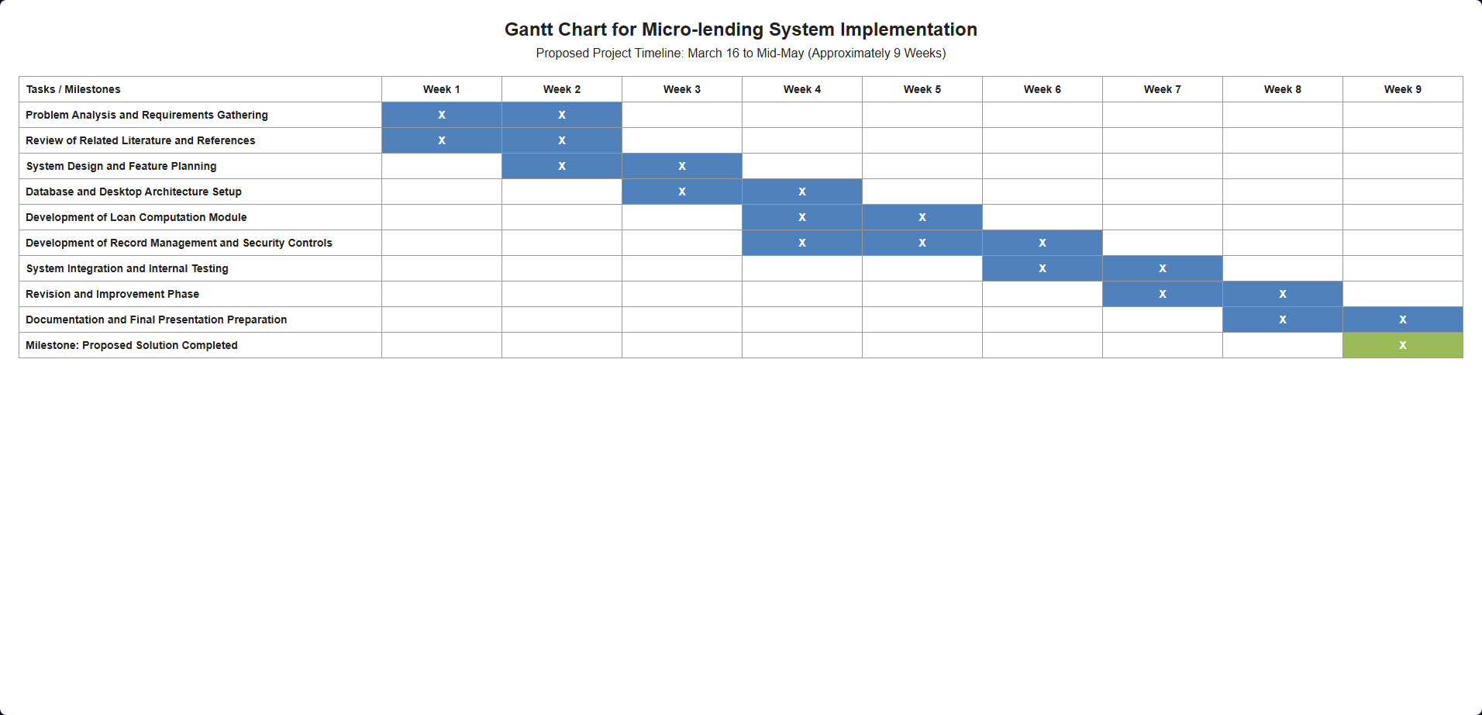

Use Case Diagram
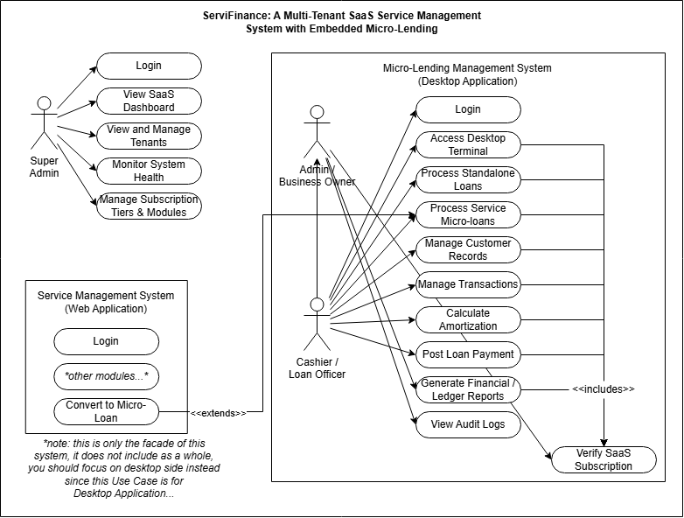
References:
Caserio, C., & Trucco, S. (2020). The impacts of ERP integration on information quality. International Journal of Management & Information Technology, 15, 1-13. https://doi.org/10.24297/ijmit.v15i.8627
International Finance Corporation. (2017). MSME finance gap: Assessment of the shortfalls and opportunities in financing micro, small, and medium enterprises in emerging markets. World Bank Group. https://openknowledge.worldbank.org/entities/publication/ff4c9839-21ac-5676-a23a-7cf6f745df0c
National Institute of Standards and Technology. (2024a). Protecting controlled unclassified information in nonfederal systems and organizations (NIST SP 800-171 Rev. 3). https://nvlpubs.nist.gov/nistpubs/SpecialPublications/800-171r3/NIST.SP.800-171r3.html
National Institute of Standards and Technology. (2024b). Assessing security requirements for controlled unclassified information (NIST SP 800-171A Rev. 3). https://nvlpubs.nist.gov/nistpubs/SpecialPublications/800-171Ar3/NIST.SP.800-171Ar3.html
Panko, R. (2016). What we don't know about spreadsheet errors today: The facts, why we don't believe them, and what we need to do. arXiv. https://doi.org/10.48550/arXiv.1602.02601

